Task 01 :

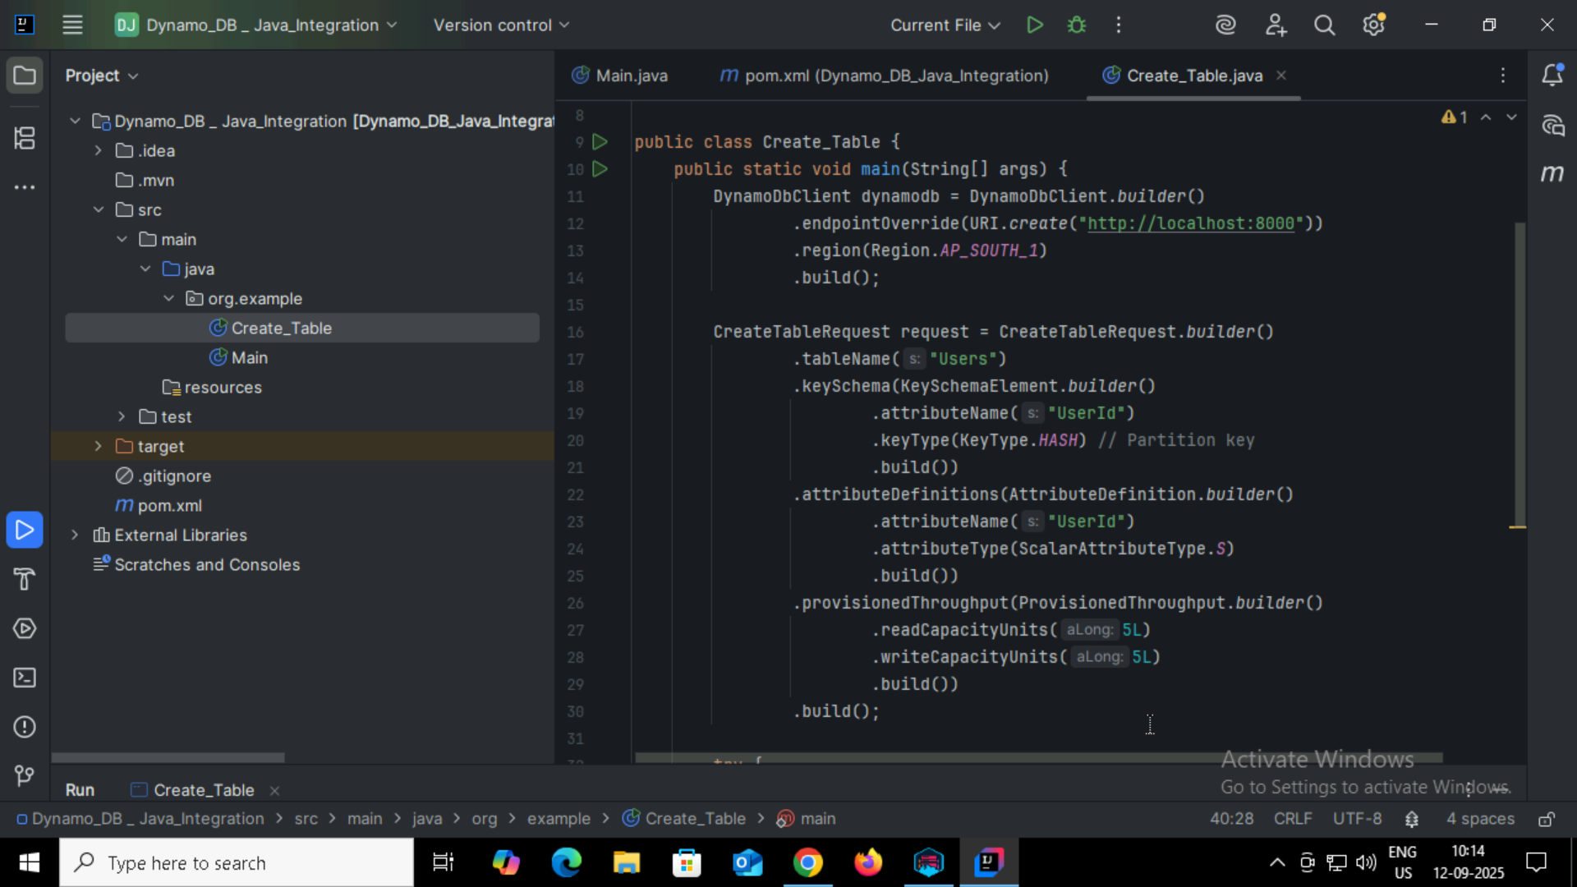

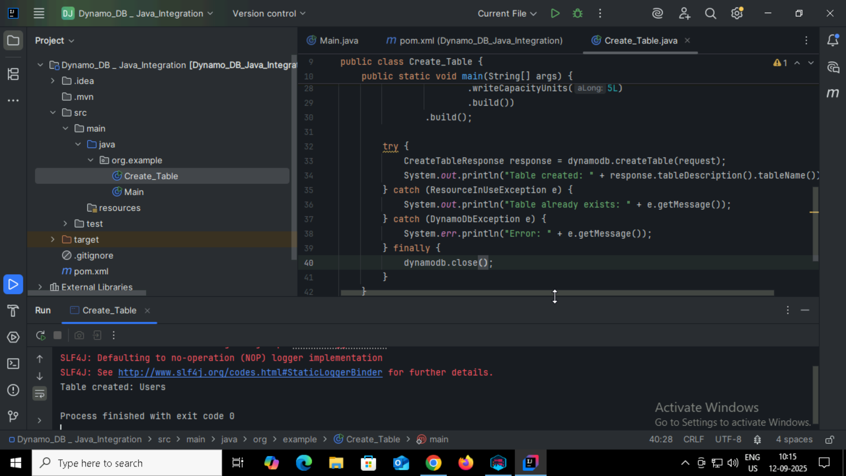

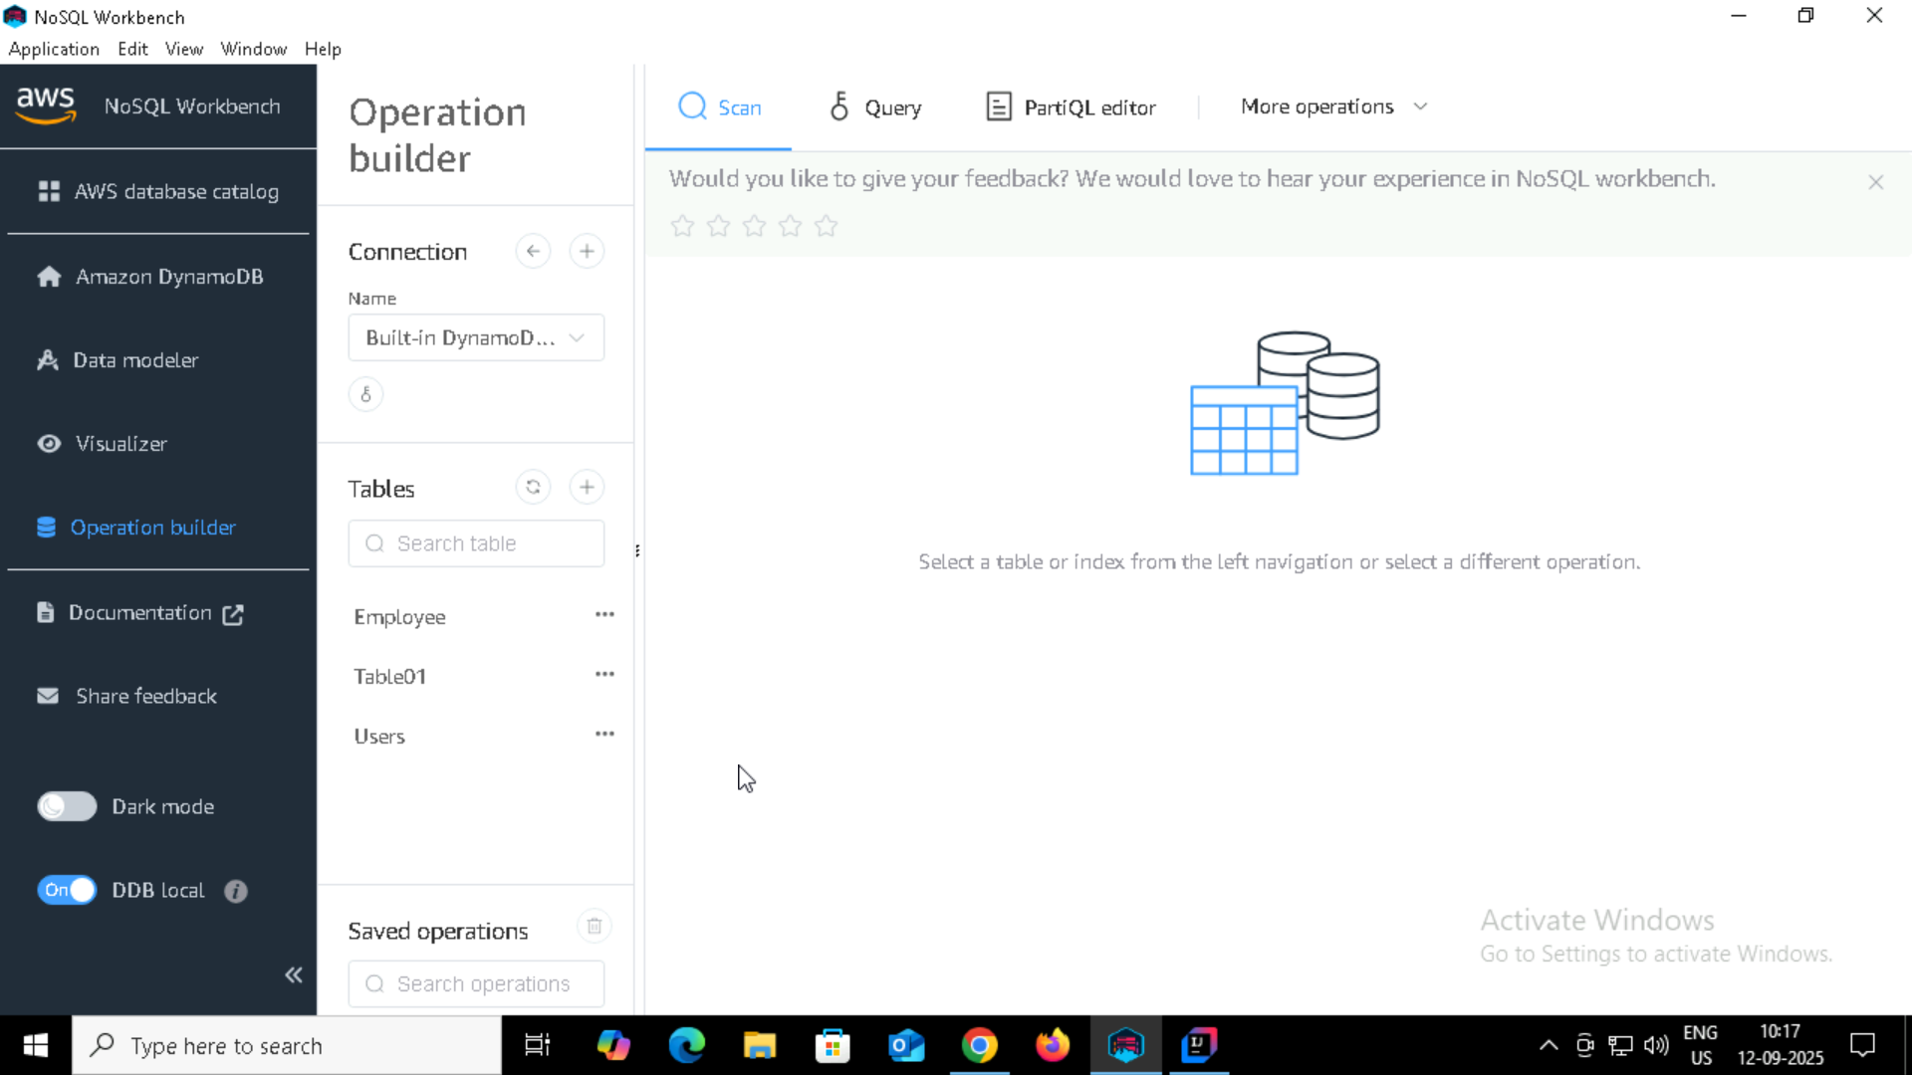

Task 02:

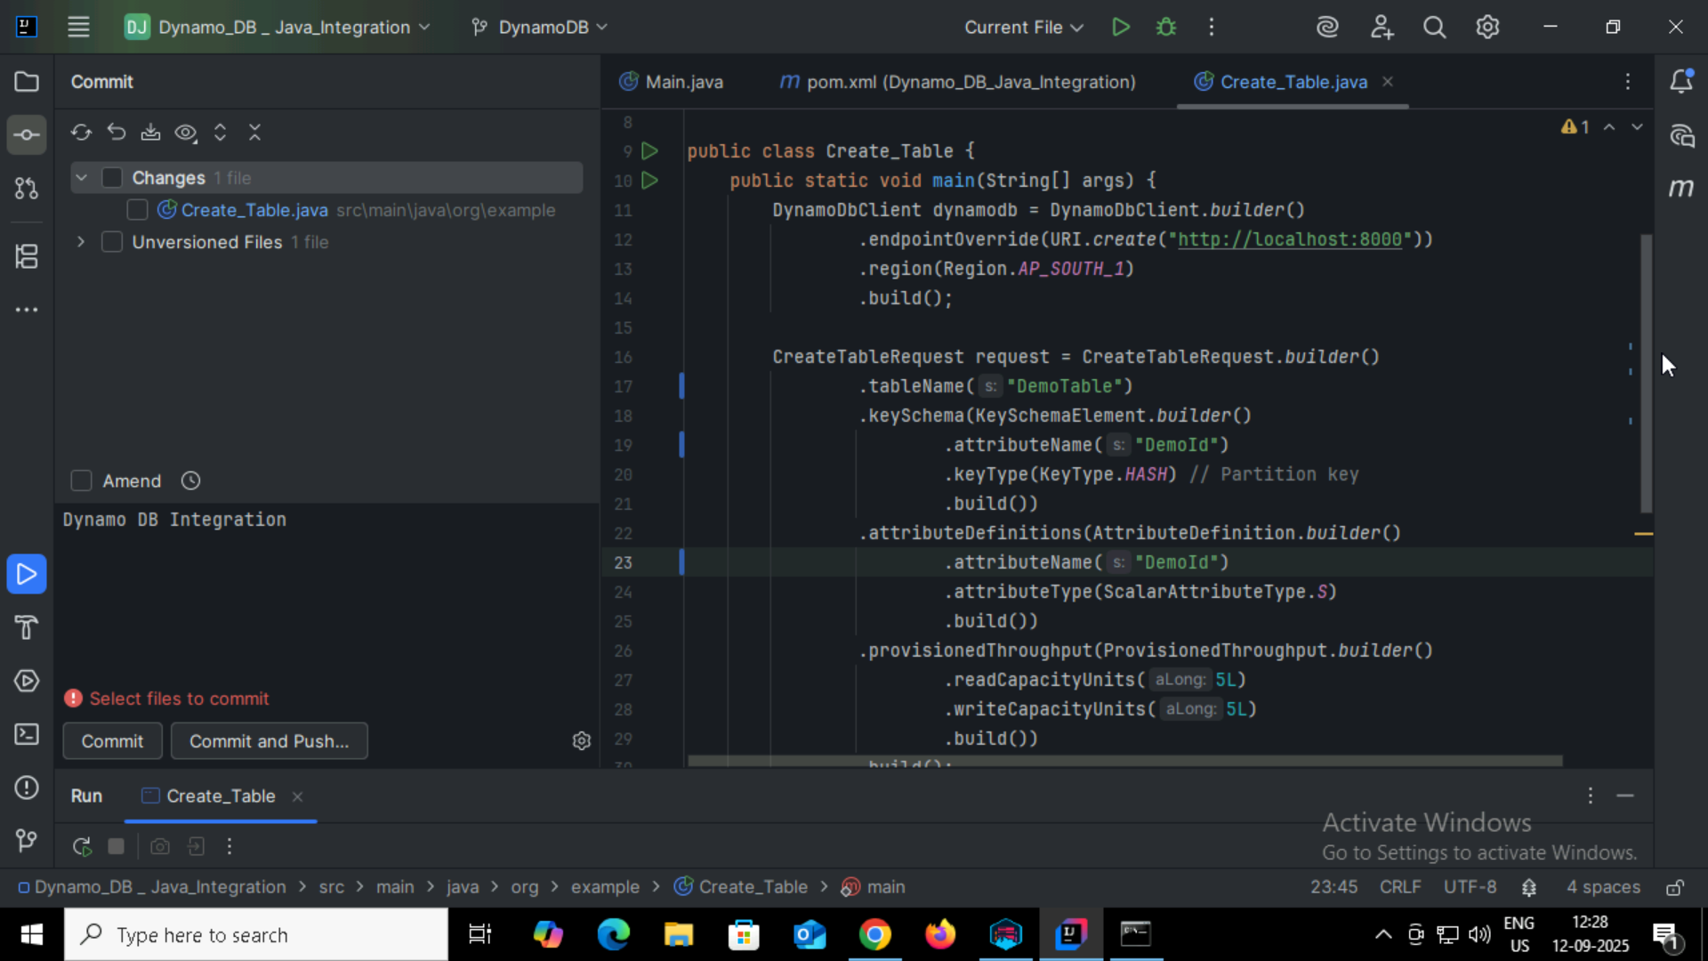

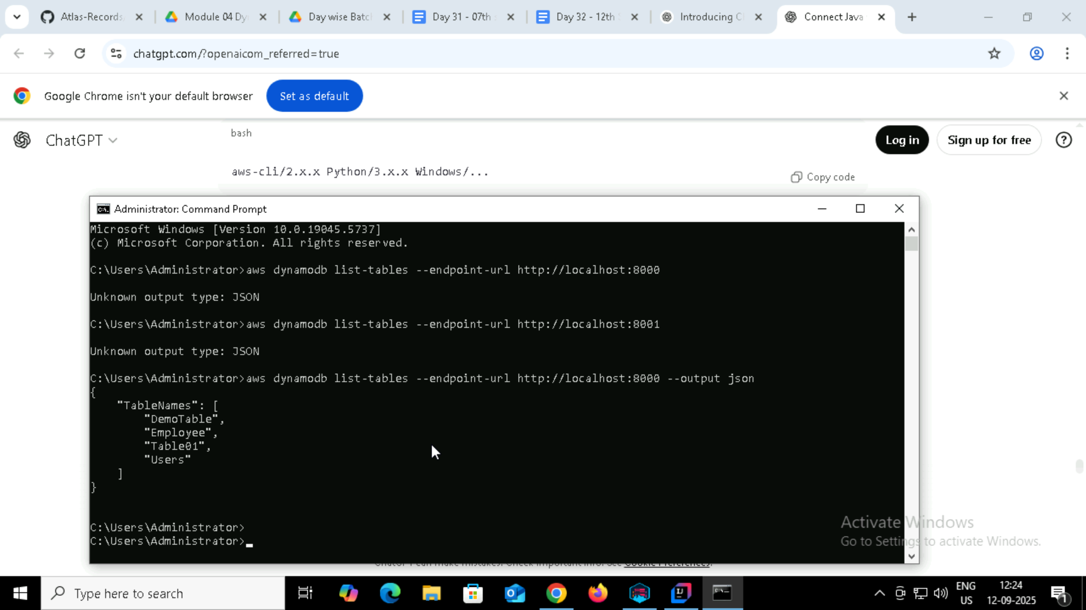

Task 3:

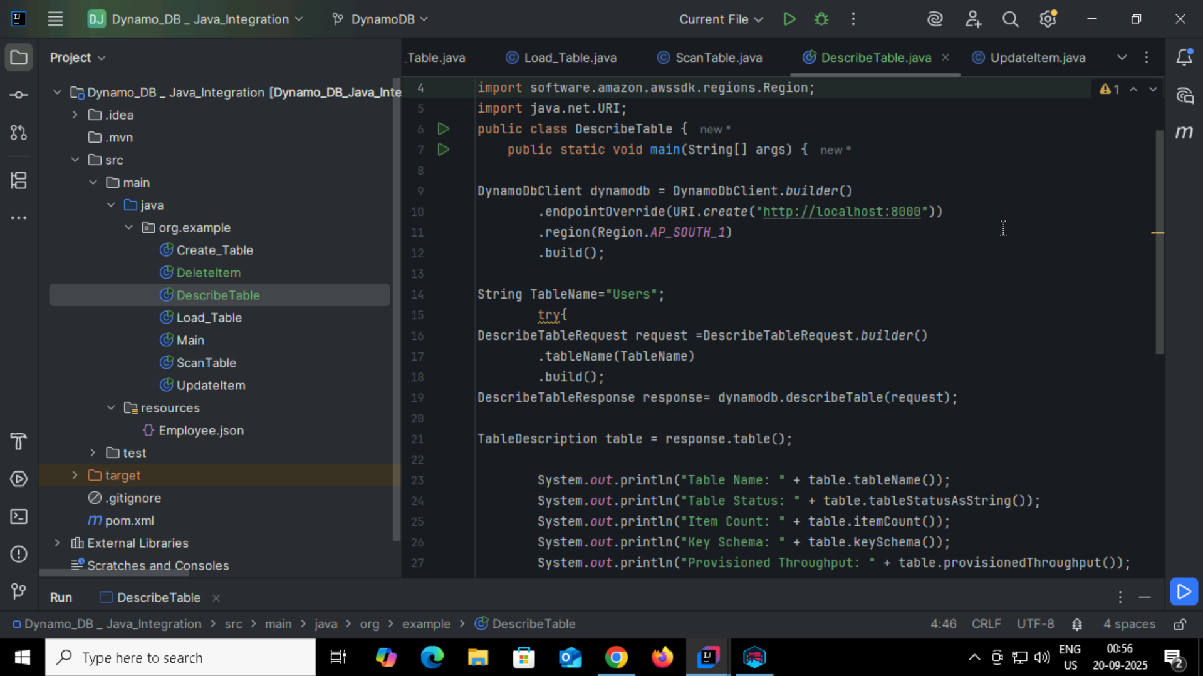

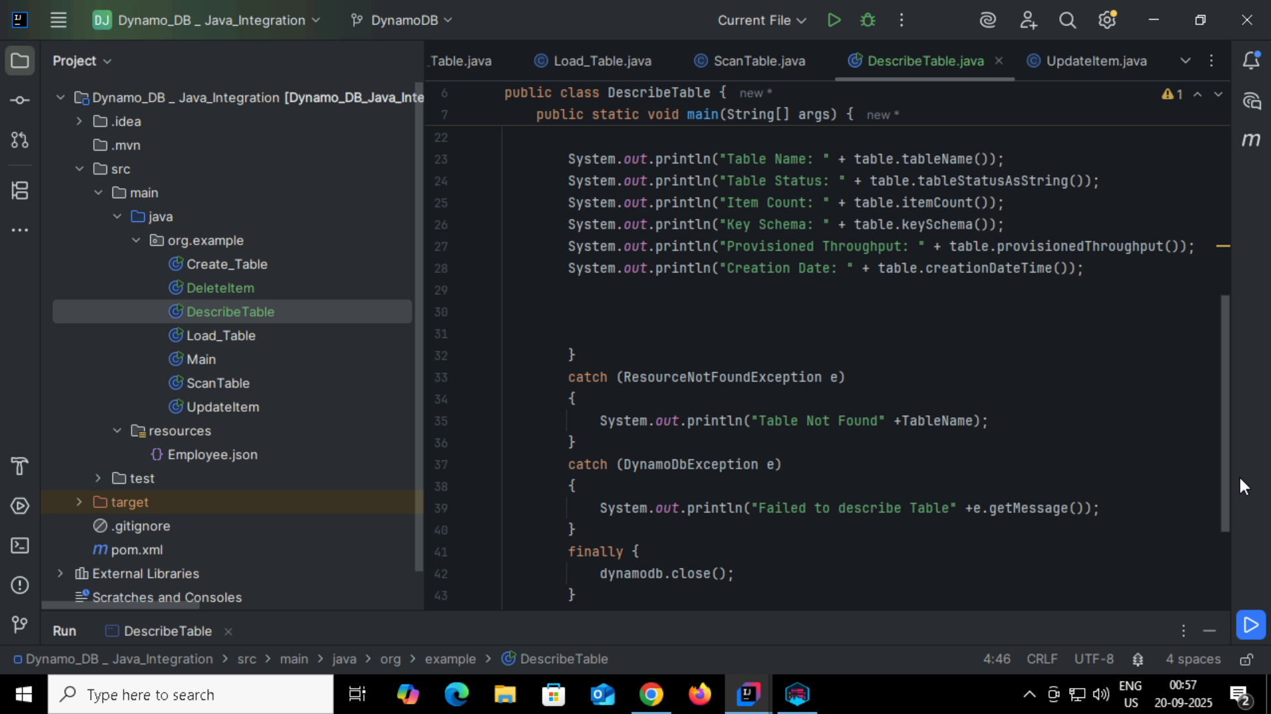

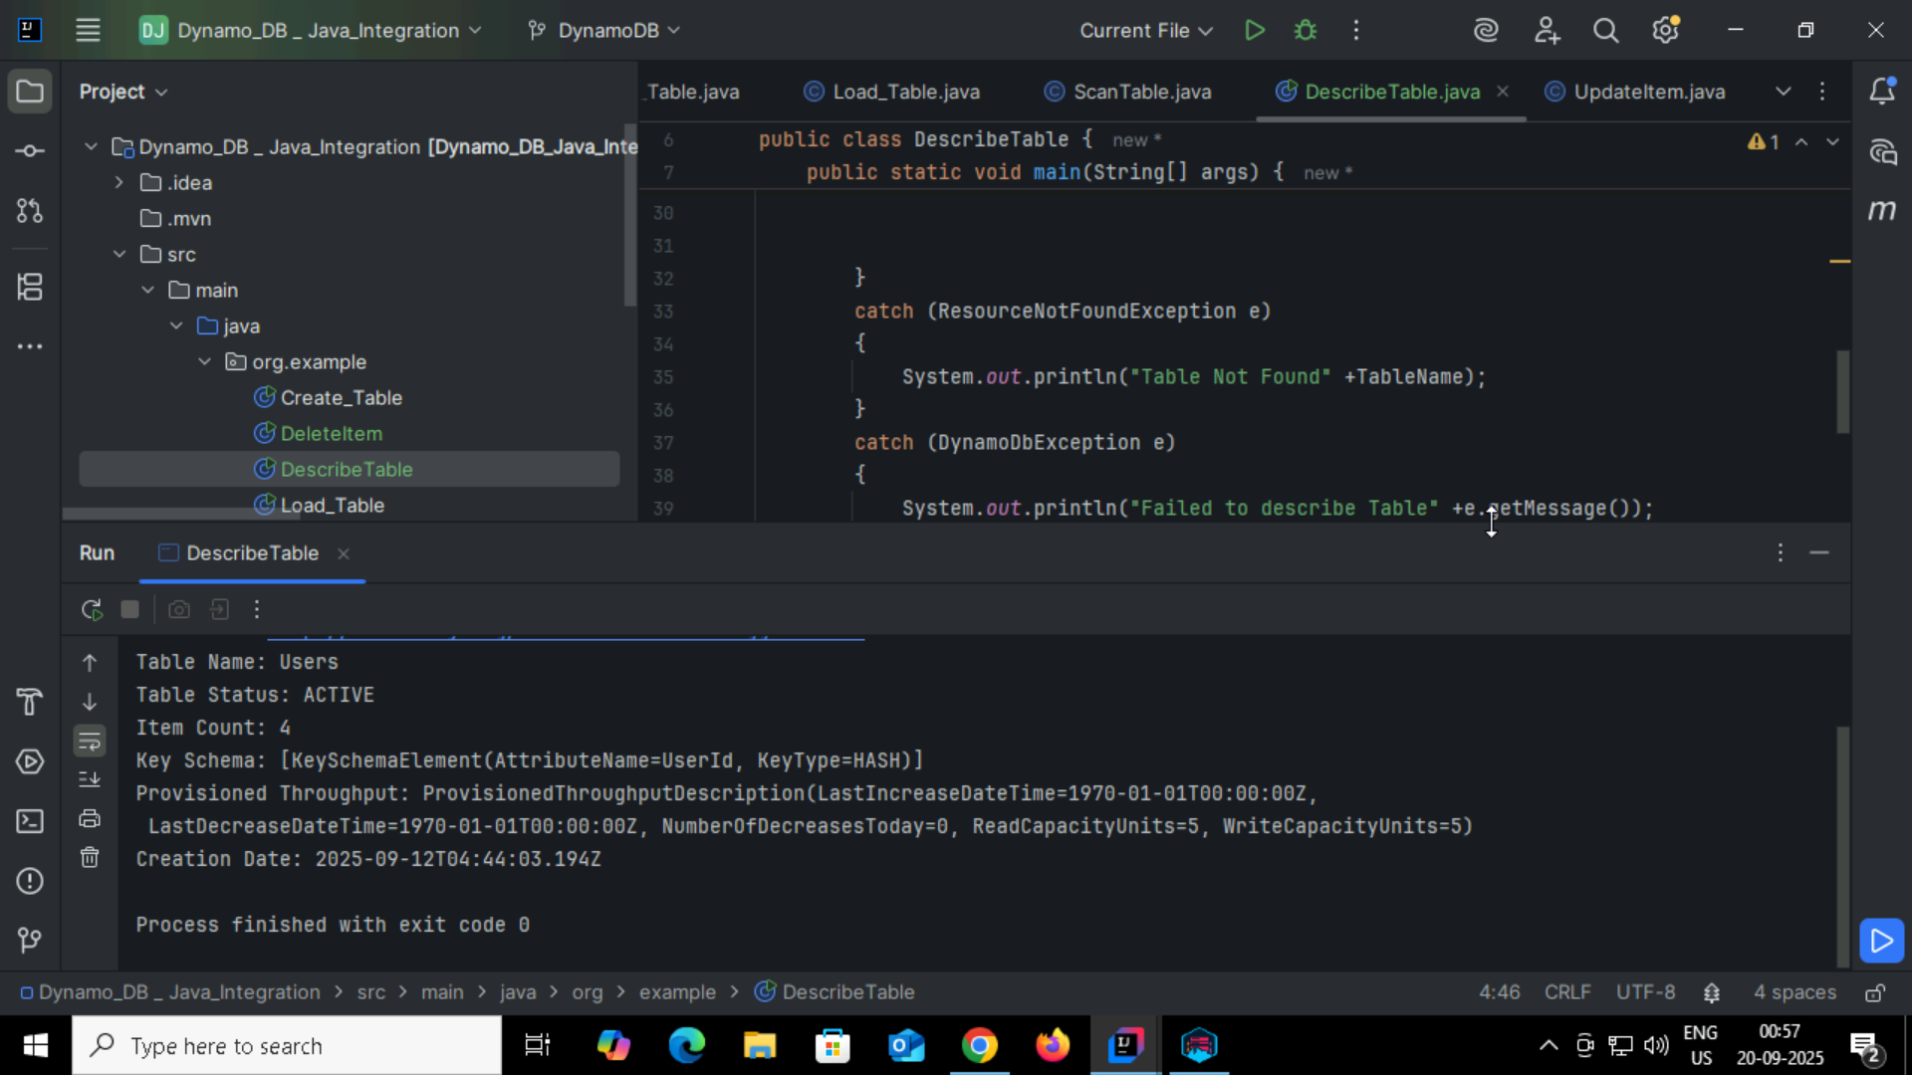

Task 4:

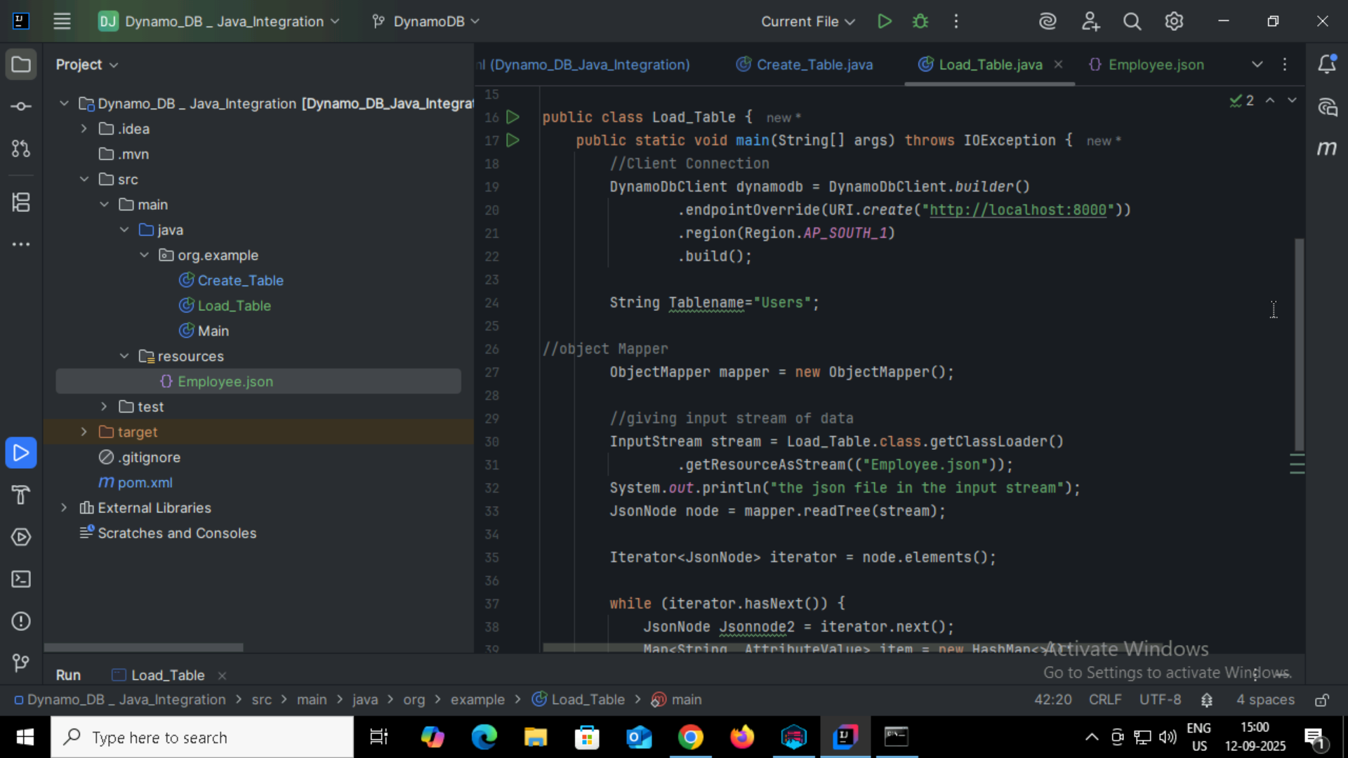

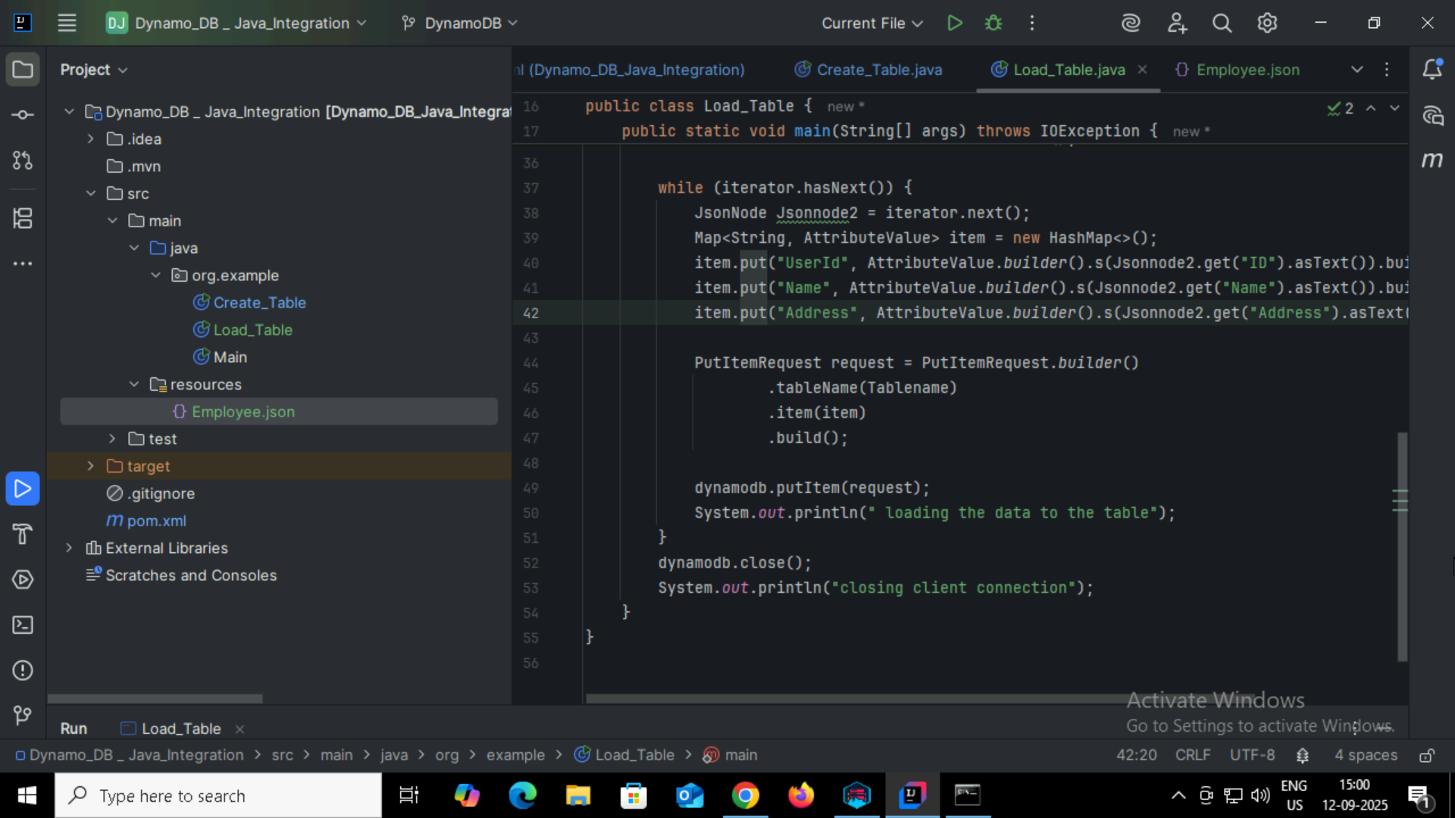

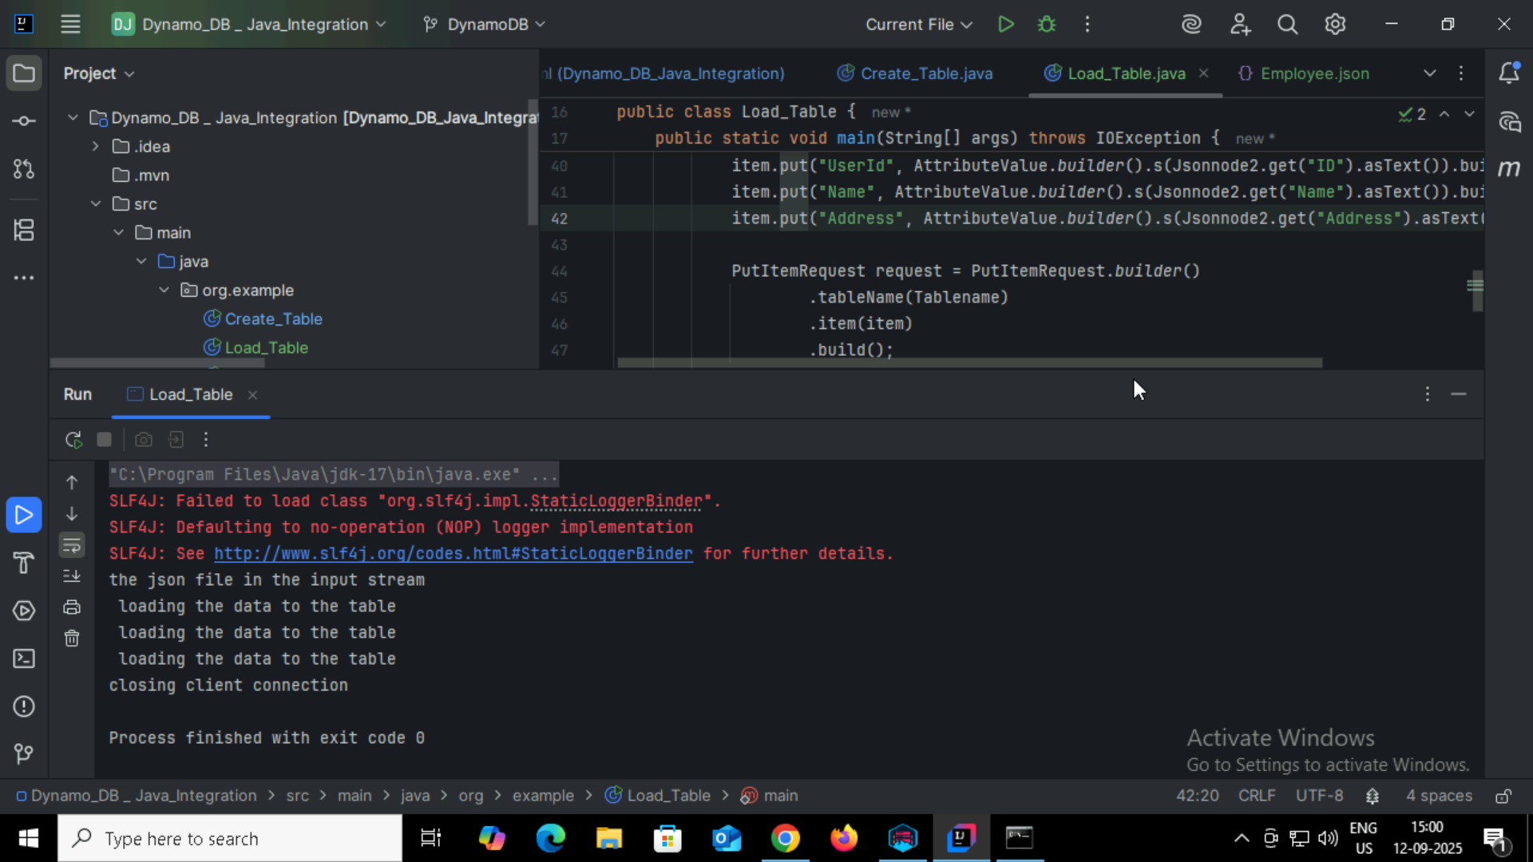

Task 05:

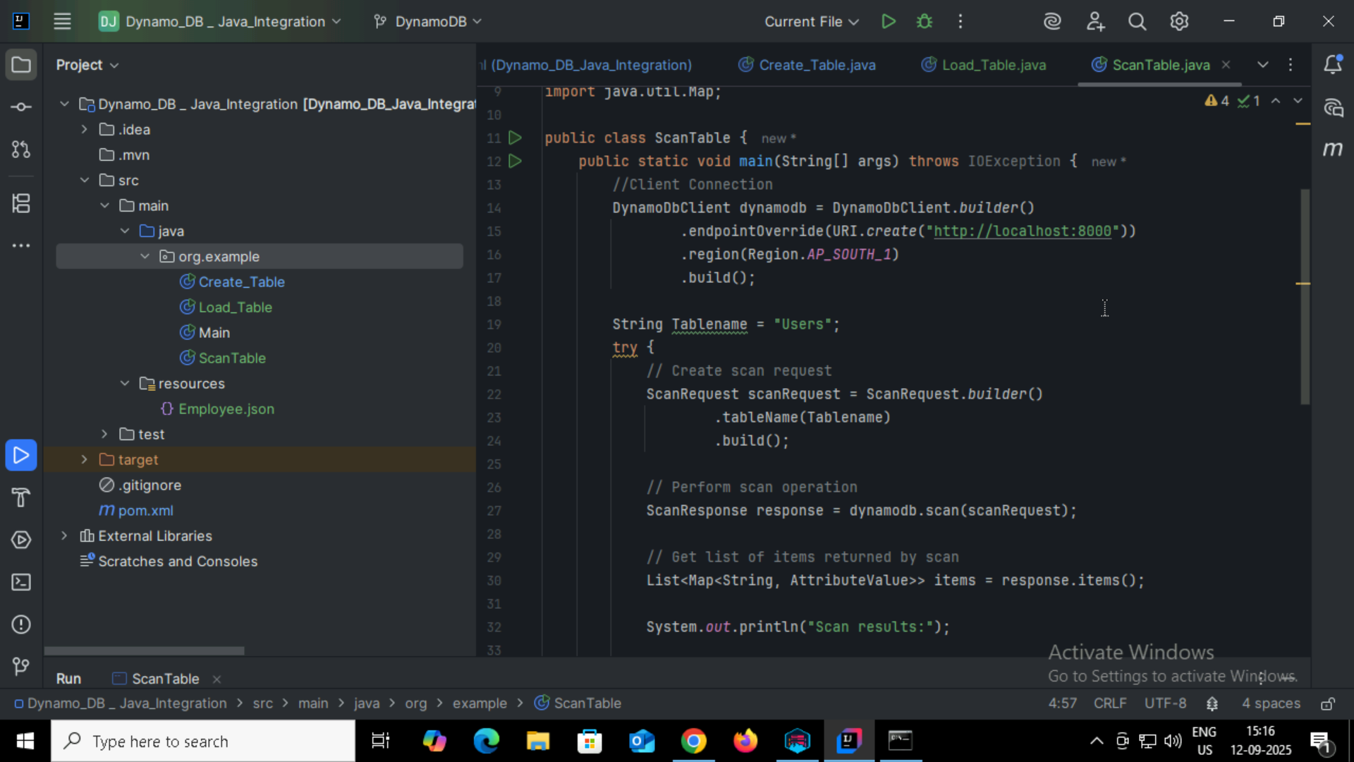

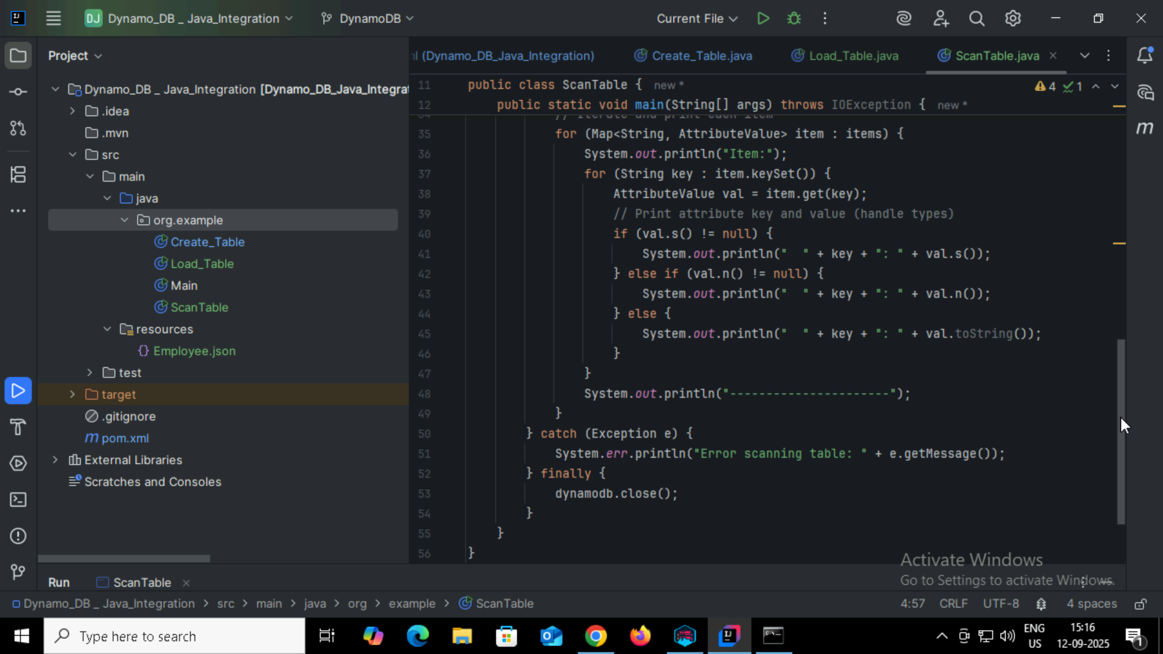

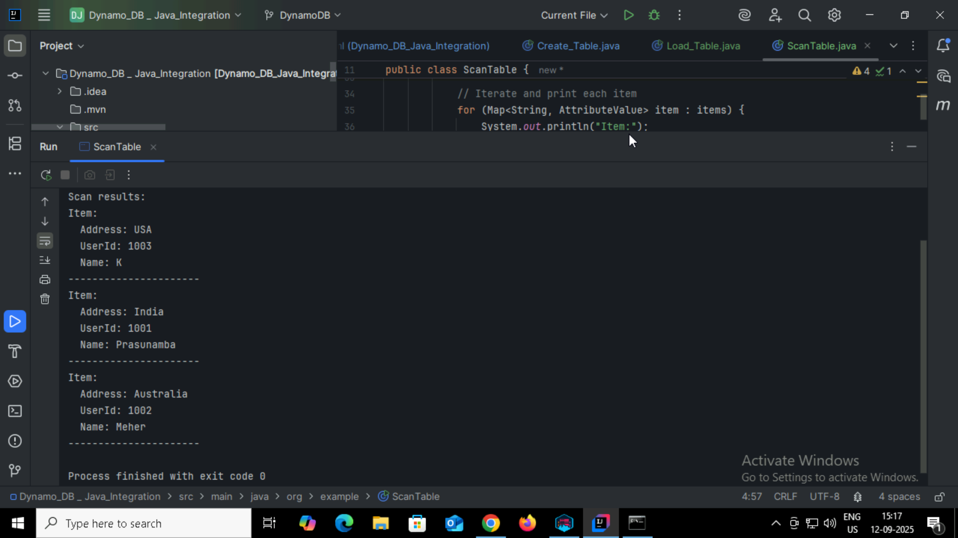

Task06:

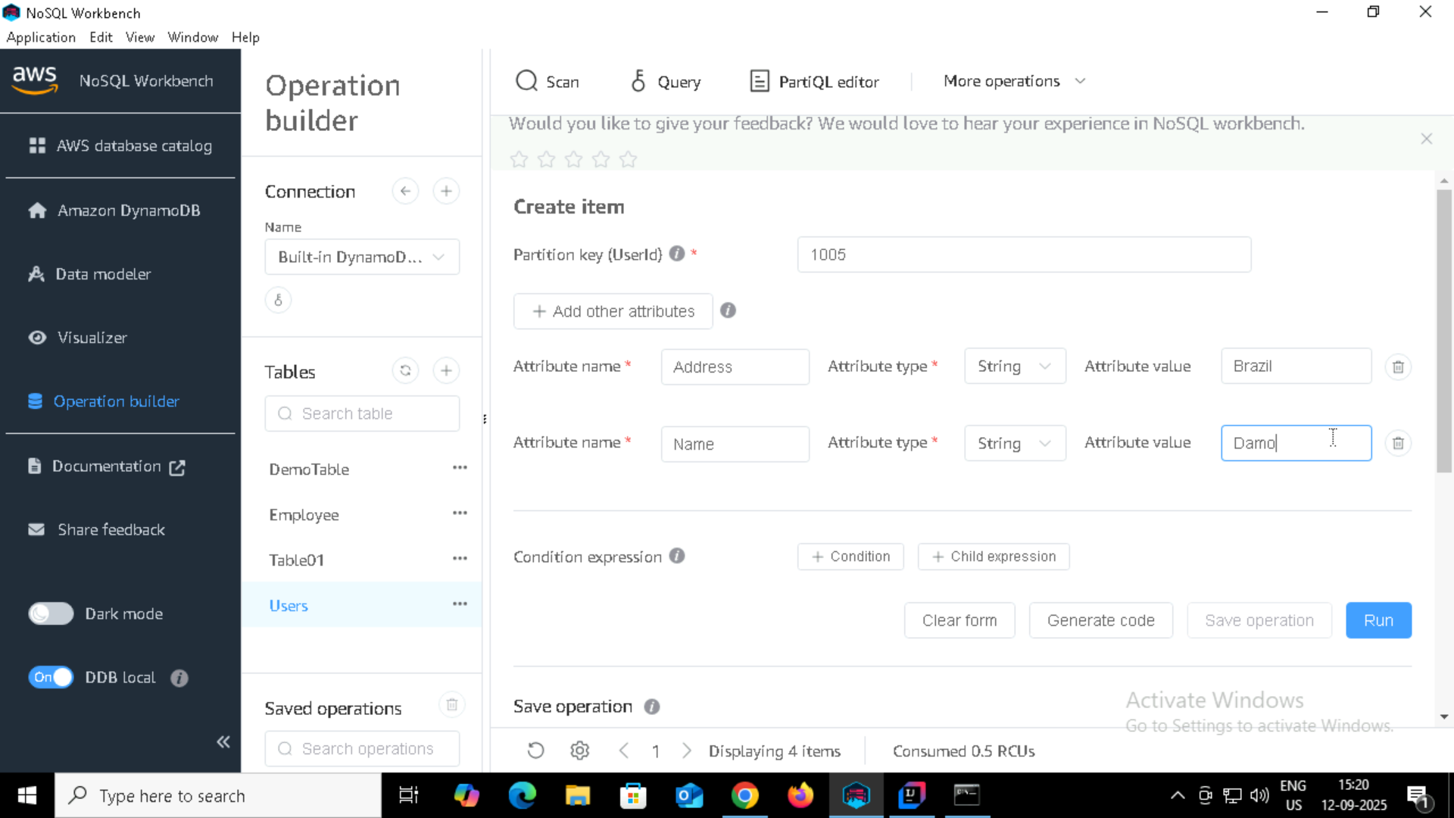

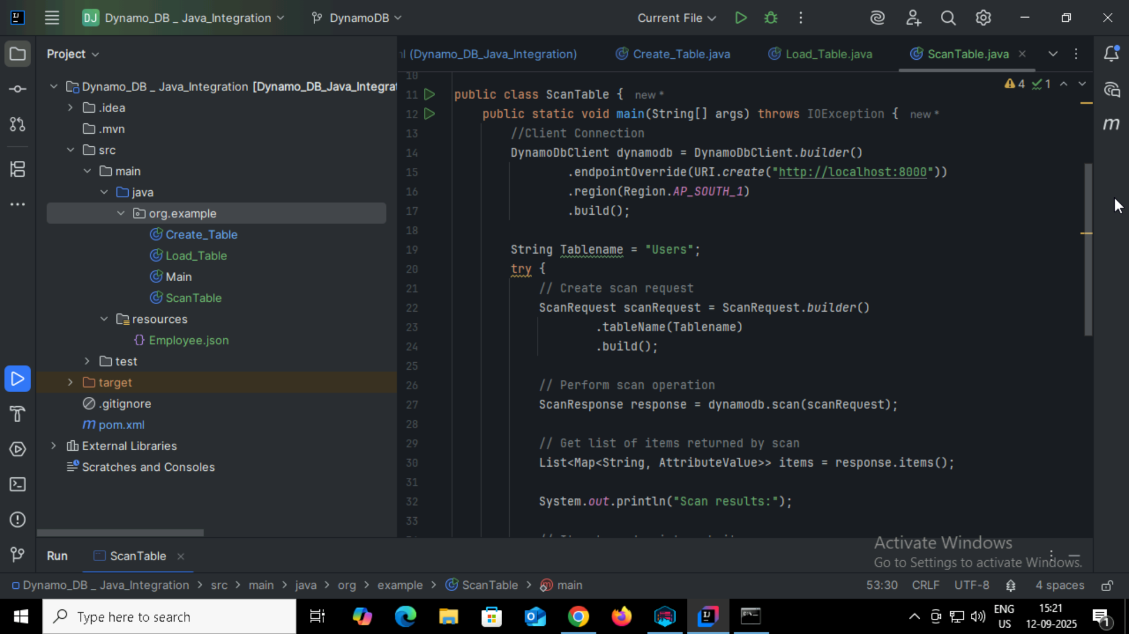

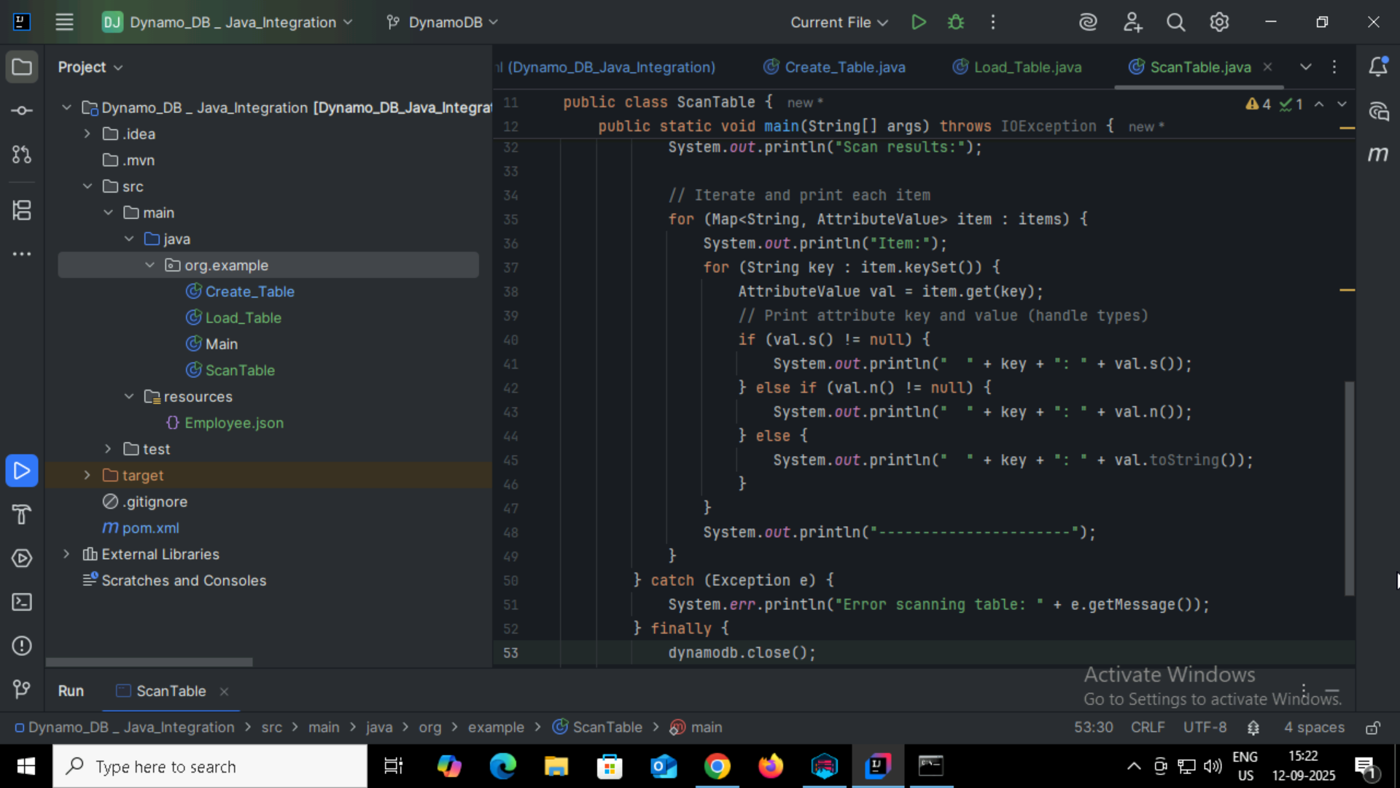

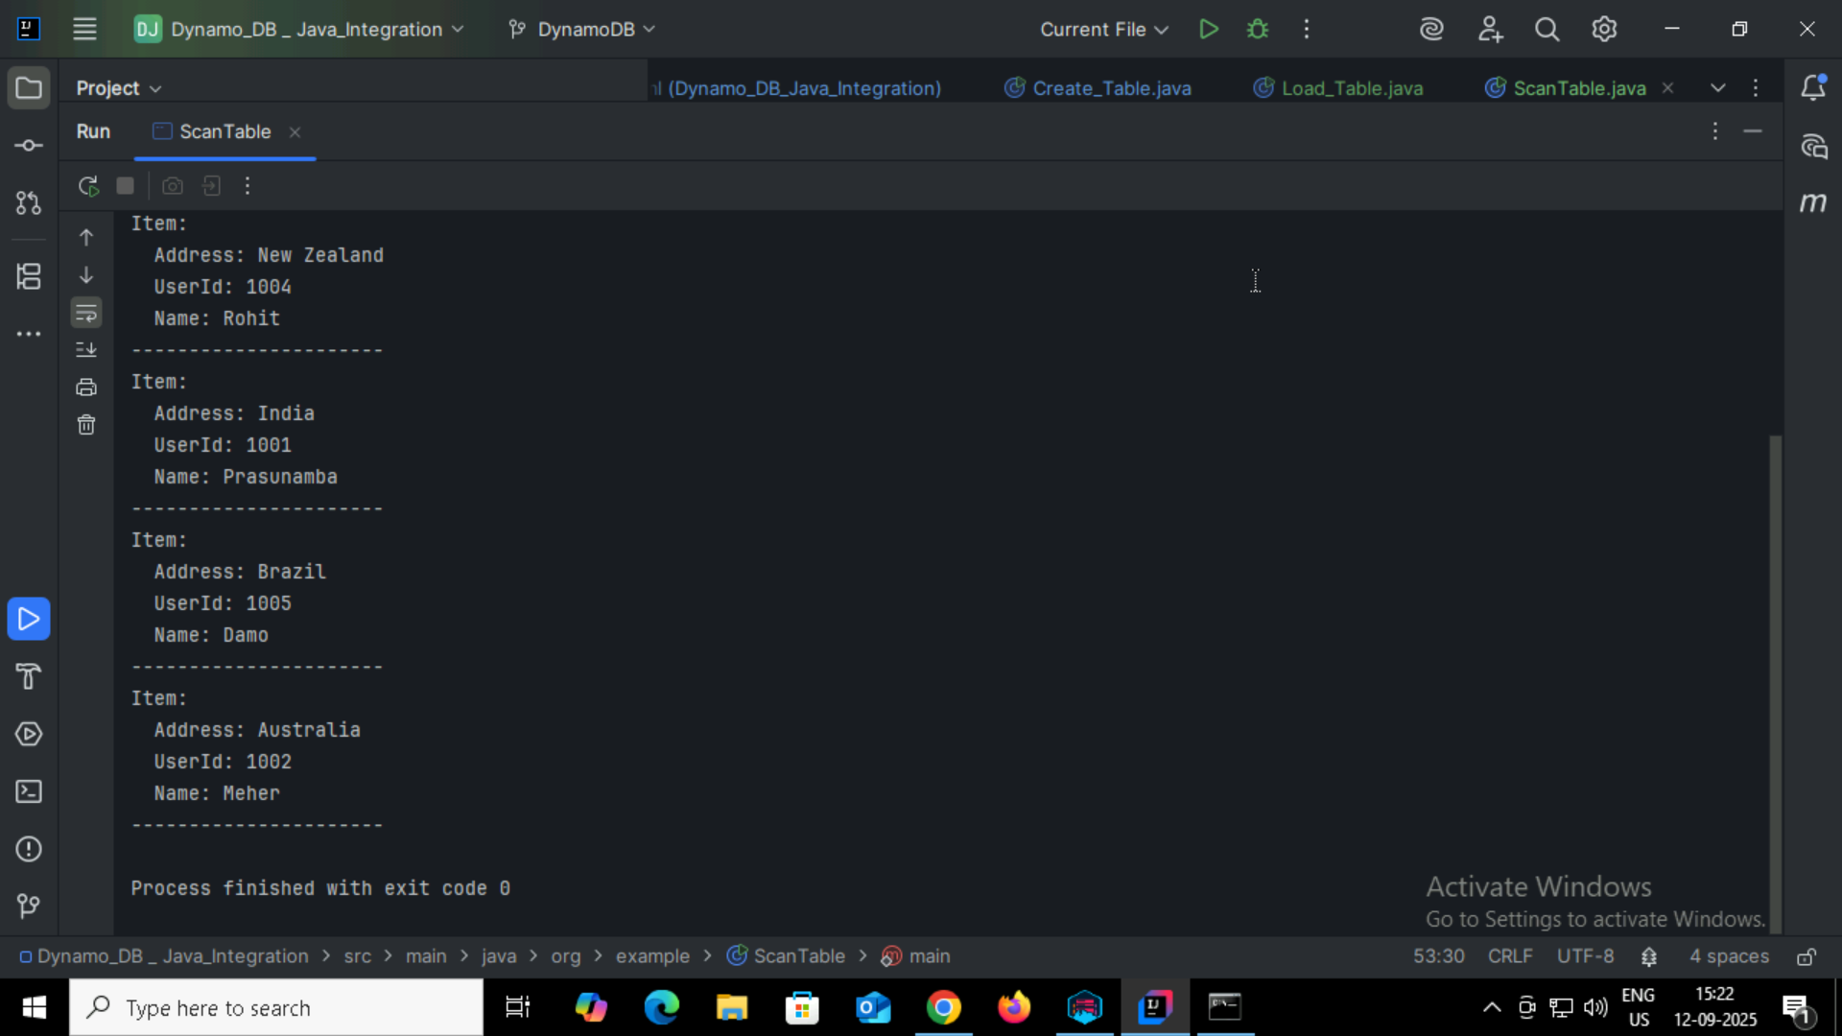

Task07:

How do you lower the cost of DynomaDB..explain ways to do so

There are few ways in which we can reduce the cost of DynamoDB

1. Choosing the right capacity mode
2. Use DynamoDB Auto Scaling
3. Optimize Table Design
4. Use DynamoDB Accelerator
5. Store large objects in S3
6. Use reserved capacity

Task08:

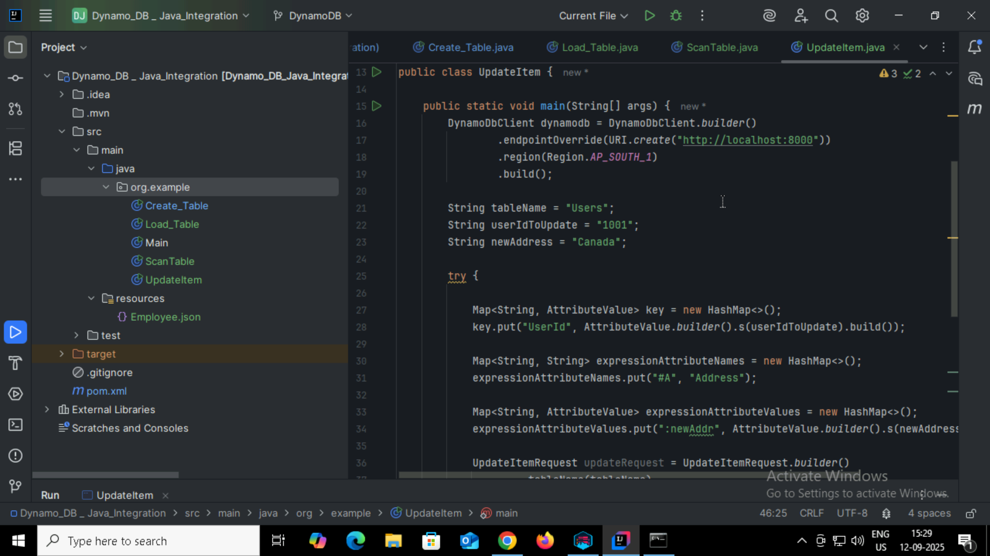

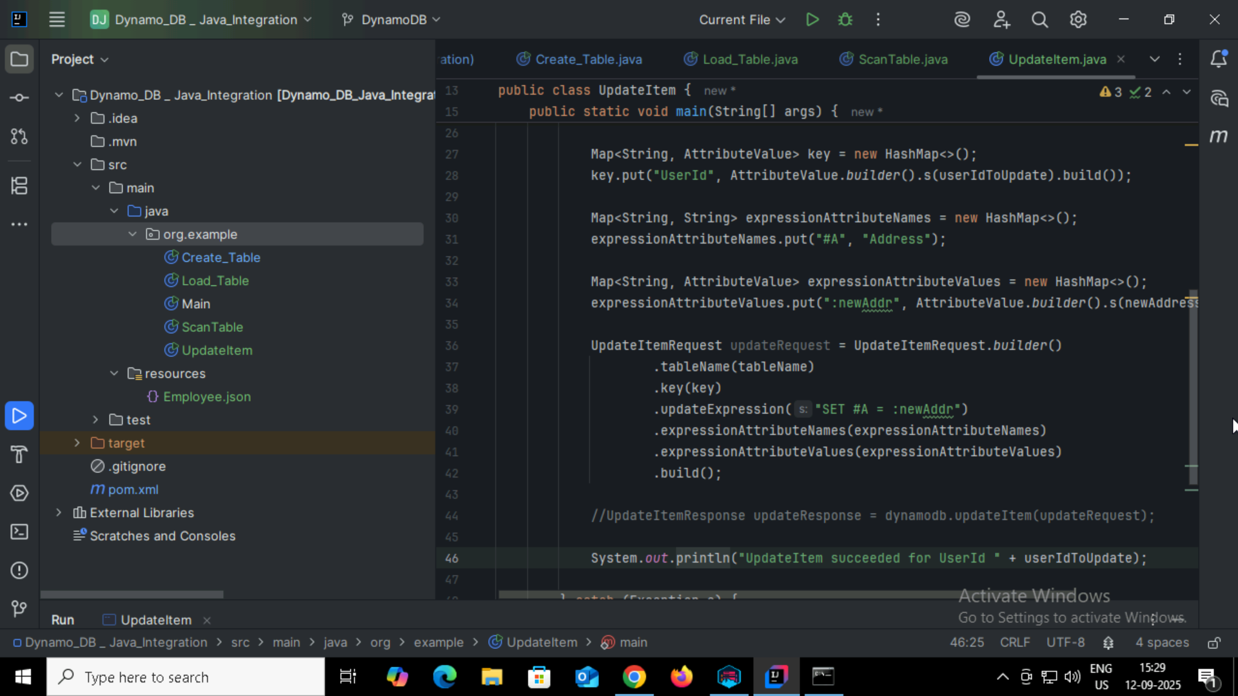

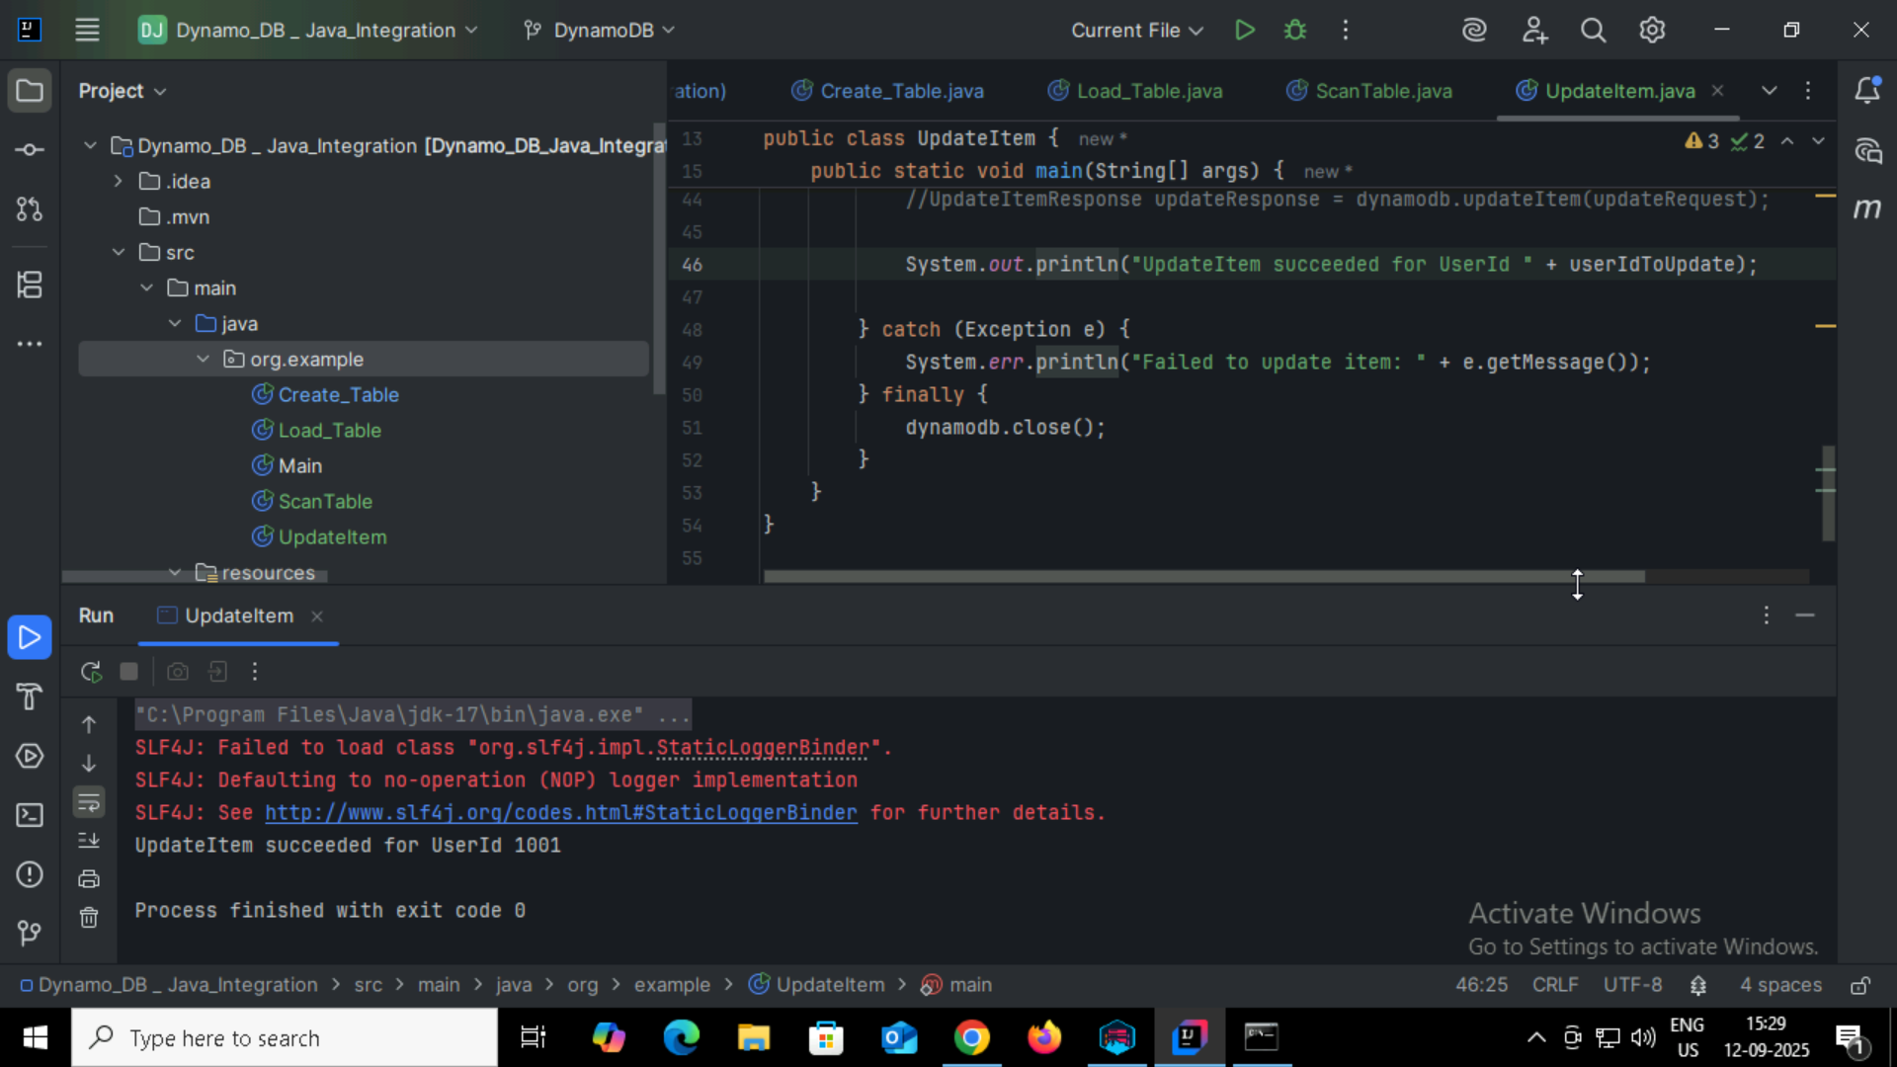

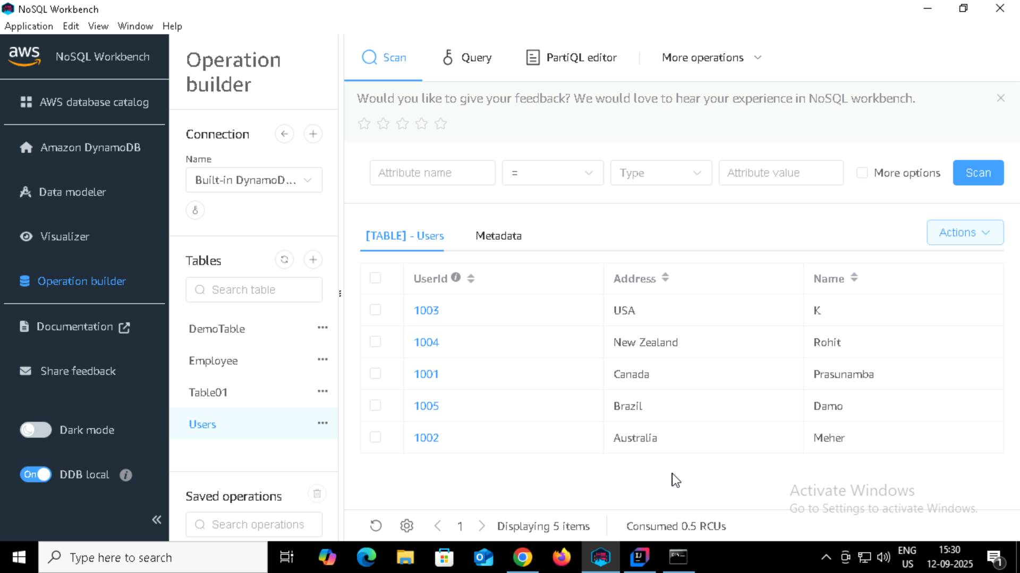

TASK09:

Delete a Item

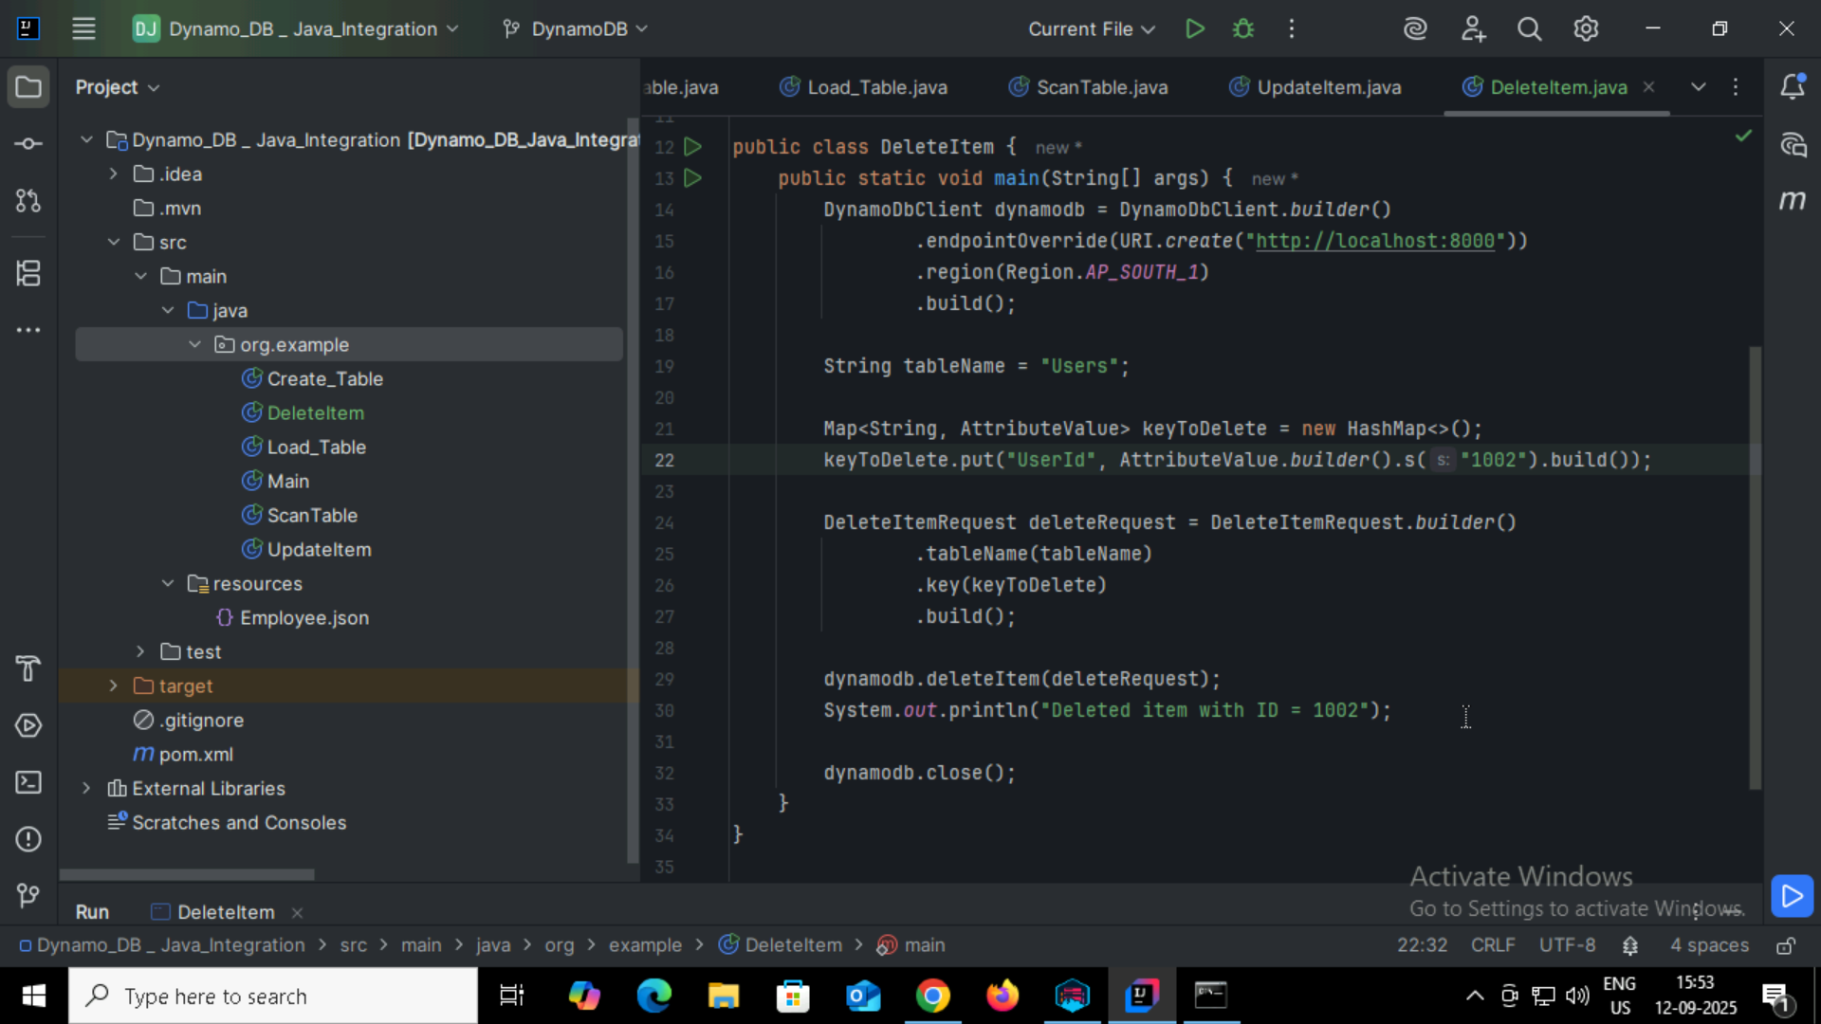

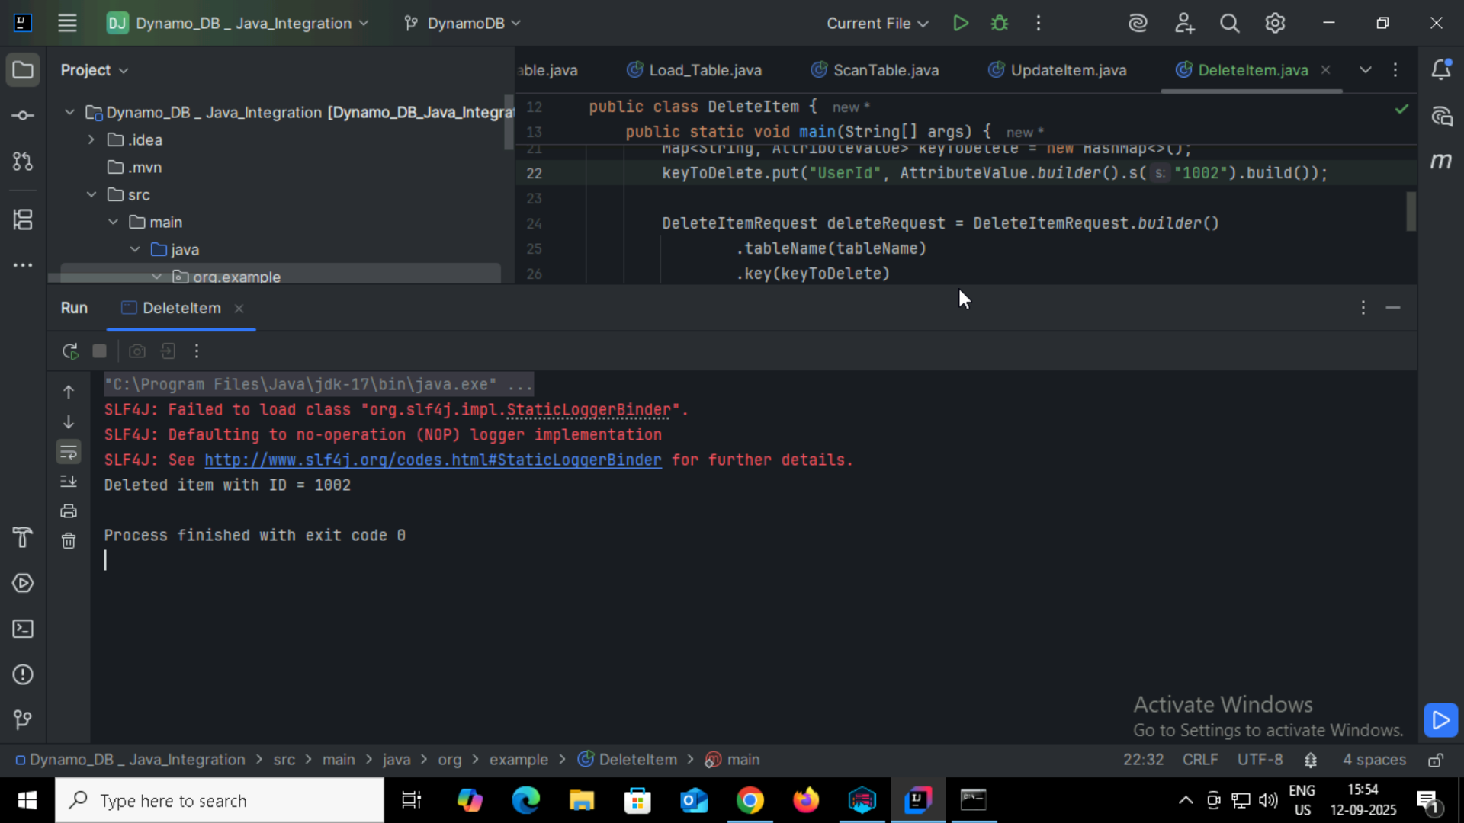

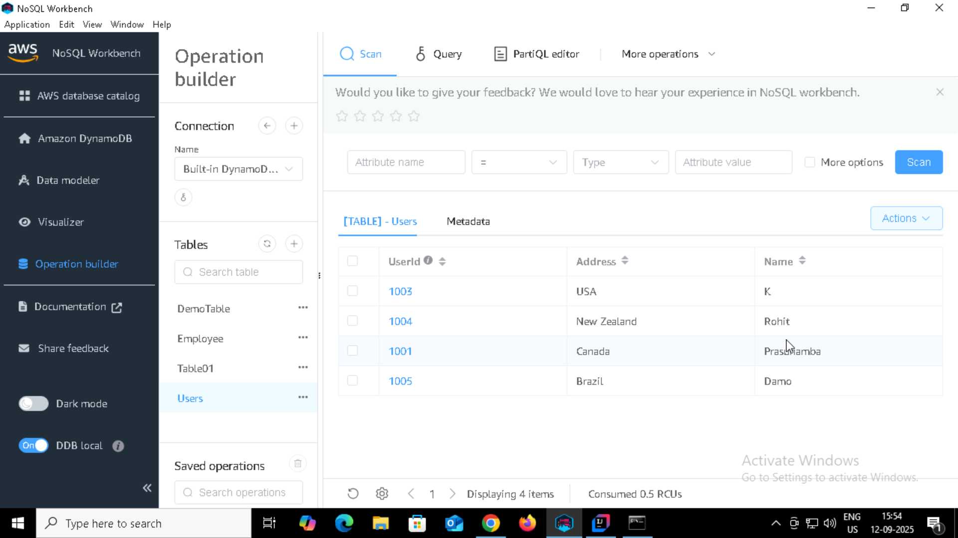

Home task:

Task 01:

What are the features of DynamoDB?

Amazon DynamoDB is a fully managed NoSQL database service from AWS.

Key Features:

* Fully Managed
* High Performance and Low Latency
* Serverless and Scalable
* Flexible Data Model
* Event-Driven Integration
* Global Tables
* Fine-Grained Access Control
* Built-in Security
* Conditional Operations
* Atomic Counters

Task 02:

What are the advantages and disadvantages of Dynamodb

| **Advantages** | **Disadvantages** |
| --- | --- |
| Fully managed, no server maintenance | Limited query flexibility |
| Low-latency, high-performance | Cost can be high for heavy write workloads |
| Serverless & auto-scaling | Eventual consistency by default |
| Flexible schema (key-value, document) | No joins or multi-table relational queries |
| Global tables & multi-region support | Item size limited to 400 KB |
| Event-driven integrations (Streams) | Learning curve for key/index design |
| Security: IAM, encryption |  |
| Atomic operations & conditional writes |  |
| Backup & PITR(point In time recovery) |  |
| TTL support(Time to live) |  |

Task 03:

Where do we use dynamoDB(the uses cases of DynamoDb)

* Real-Time Applications
* Web and Mobile Applications
* E-commerce Platforms
* Analytics and Metrics
* Serverless Architectures
* Content Management
* Leaderboards and Counters
* Microservices
* Global Applications

Task 04:

What is DynamoDBMapper?

DynamoDBMapper is a high-level Java library provided by AWS SDK that simplifies interaction with Amazon DynamoDB by mapping Java objects (POJOs) to DynamoDB tables. It allows developers to perform database operations like create, read, update, delete, and query without writing low-level DynamoDB API calls.

Task 05:

What are projections in DynamoDB?

In DynamoDB, projections refer to the attributes (columns) that are copied from a base table into a secondary index. When you create a Global Secondary Index (GSI) or Local Secondary Index (LSI), you can choose which attributes should be available in the index to optimize queries and reduce storage costs.

Task 06:

How can you say DynamoDB prevents Dataloss?

* Automatic Multi-AZ Replication( Multiple Availability Zones)
* Durable Storage
* Atomic Operations
* Point-in-Time Recovery (PITR)
* Streams for Backup and Replication
* Managed Service Guarantees

Task 07:

What is in-place atomic update means ..? do you think your dynamoDb supports it?

In-place atomic update means updating a specific attribute of an item in the database without reading the entire item first, and the update is atomic, i.e., it happens as a single, indivisible operation. This ensures no race conditions even if multiple clients try to update the same attribute simultaneously.

Dynamodb supports in-place Atomic update.

Task 08:

What are Streams in DynamoDb?

DynamoDB Streams are time-ordered sequences of item-level changes in a DynamoDB table. They capture insert, update, and delete operations and store them for up to 24 hours.

Task 09:

What are DynamoDB Pricing tiers?

* **On-Demand Capacity Mode** – Pay per read/write request without provisioning capacity.
* **Provisioned Capacity Mode** – Predefine read and write capacity units (RCUs/WCUs).
* **Reserved Capacity** – Commit to a certain capacity for a 1- or 3-year term for cost savings.
* **Storage Costs** – Charges for data storage per GB per month.
* **Data Transfer Costs** – Charges for data transferred out of DynamoDB to the Internet or other AWS regions.
* **Additional Features** – Optional costs for features like **DynamoDB Streams**, **Global Tables**, **Backup and Restore**, and **On-Demand Backup**.

Task 10:

Do you have any max limit for Item Size in DynamoDb? If so what is it?

Yes. DynamoDB has a maximum item size limit of 400 KB.

* This includes the attribute names and values.
* Binary attributes count toward this limit as well.
* If you need to store larger objects, you would typically use Amazon S3 for the bulk data and store only a reference (like an S3 URL) in DynamoDB.

Task 11:

At a max of how many GSI’s Global Secondary Indexes can you create in a table?

In DynamoDB, you can create up to 20 Global Secondary Indexes (GSIs) per table by default.

* Each GSI consumes additional provisioned throughput or on-demand capacity.
* You can request a limit increase through AWS Support if needed.

Task 12:

What is DynamoDb Accelerator?

DynamoDB Accelerator (DAX) is an in-memory caching service for DynamoDB that provides fast read performance by reducing response times from milliseconds to microseconds.

Task 13:

What are DynamoDB Global tables?

DynamoDB Global Tables are multi-region, fully replicated tables that provide low-latency, high-availability access to data across different AWS regions.

Task 14:

What are indexes and Secondary indexes in DynamoDB?

Indexes in DynamoDB are structures that allow you to query data efficiently without scanning the entire table. They provide alternate access patterns for your data.

Secondary Indexes are a type of index that lets you query on attributes other than the primary key.

Task 15:

What are Hot Keys and Hot Partitions?

**Hot Key:**

* A partition key value that receives a disproportionately high number of read or write requests.
* Example: If most users access userID = 123, that key becomes a hot key.

**Hot Partition:**

* A partition in DynamoDB that stores one or more hot keys.
* Can cause throughput throttling, because DynamoDB distributes capacity evenly across partitions, and one hot partition can exceed its allocated IOPS.

Task 16:

What are Table level operations and Item level operations in DynamoDB?

**Table-Level Operations in DynamoDB:**  
Operations that affect the entire table and its structure:

* **CreateTable** – Create a new DynamoDB table.
* **UpdateTable** – Modify table settings (provisioned throughput, indexes, etc.).
* **DeleteTable** – Remove a table and all its data.
* **DescribeTable / ListTables** – Retrieve metadata about tables.

**Item-Level Operations in DynamoDB:**  
Operations that affect individual items (rows) within a table:

* **PutItem** – Add a new item or replace an existing item.
* **GetItem** – Retrieve a single item using its primary key.
* **UpdateItem** – Modify attributes of an existing item.
* **DeleteItem** – Remove a single item from the table.
* **BatchGetItem / BatchWriteItem** – Perform multiple item-level operations in one request.